Note: This document is “view only”. Please create a copy of this document and save it to your drive.

**SOP- Real Time Team Communication- Systems Vault**

**PREREQUISITES**

[Master : SOP- Team Member Training & Ongoing - Systems Vault](https://docs.google.com/document/u/0/d/1ehsSFDBKm1GDYCPYGj_QW-rHjlUrTM5uk6D0EKqtfQM/edit)

[Teamwork Chat](https://sarahnoked.teamwork.com/chat/channels/43094)

<https://www.teamwork.com/chat-apps>

**PURPOSE**

We use chat to communicate in “real time” with the team.

**POLICY**

When corresponding on [Teamwork Chat](https://sarahnoked.teamwork.com/chat/channels/43094), please use staff handles (typing “@” then their name) to ensure that the team member is notified.

Channels and chat are divided up as follows and you may have access to all our some of these channels:

PRODUCTS:

OBM CERTIFICATION  
COBM ACCELERATOR

OBM MASTERY

INTERNAL TEAM COMMUNICATION:

INTERNAL

EOD REPORTING

PROJECTS:

SN EDITORIAL & SOCIAL  
SN PROJECTS

SN PAYMENT MANAGEMENT

SN JVs & AFFILIATES

If you are corresponding with a team member privately, or on a matter that does not concern the whole team you can send direct messages to the team member.

It is recommended that all team members download Teamwork chat to their phone and desktop: <https://www.teamwork.com/chat-apps>

**PARTY**

All Team Members

**PROPERTY**

Online Business Manager

**PROCESS**

Part 1: Sending Messages in Teamwork Chat

Part 2: Assigning a task via Teamwork Chat

**PROCEDURE**

**Part 1: Sending Messages in Teamwork Chat**

**Part 1:** **Login to Teamwork Chat** [**https://sarahnoked.teamwork.com/chat**](https://sarahnoked.teamwork.com/chat)

1. Login to [Teamwork Chat](https://sarahnoked.teamwork.com/chat/channels/43094).
2. Navigate to the correct channel
3. Post your message
   1. To a single person on a channel by using @username to chat with a specific team member or use
   2. To the whole team by mentioning @all

**Part 2: Assigning tasks via Teamwork Chat**

1. To assign a task, hover over the message that you want to turn into a task
   1. Click on 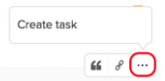
   2. Choose the project name and task list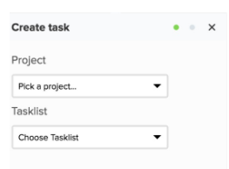
   3. Click 
   4. Add the title 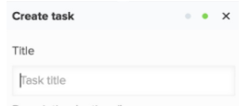
   5. Edit the task description 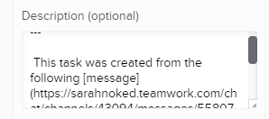
      1. Scroll down to add to, or edit the content in the message that you are sending as a task
   6. Click 
   7. Go into the project in Teamwork to change persons responsible and the due date.

**Created by:**

**Department:** Growth

**Date:**

**Revised:**

**Revised by:**